SHAPES OF SAME AREA
Pearson Edexcel - Tuesday 12 June 2018 - Paper 3 (Calculator) Higher Tier
1.
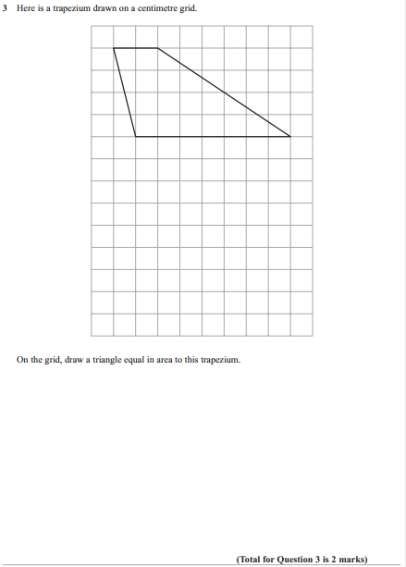

Pearson Edexcel - Monday 14 November 2011 - Paper 4 (Calculator) Higher Tier
2.
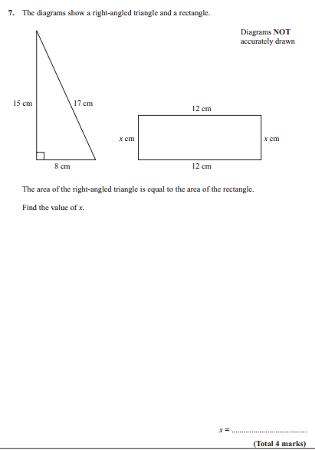
3.

